Healthy Ageing

Healthy ageing refers to activities and behaviours which aim to reduce the risk of illness and disease, and increase physical, emotional and mental health during the ageing process. It is concerned with the quality of life, not just the years of life, enjoyed by an individual.
Evidence shows that today’s older Australians are living longer and, in several respects, healthier lives than previous generations. According to the 2007–08 National Health Survey, the majority of older Australians consider themselves to be in excellent, very good or good health, although the proportion of older females reporting fair or poor health increases with age. Thus, many older people have a positive view of their health even though older age may be generally associated with increasing levels of disability and illness.
Inquiry

- Outline the reasons why Australia’s population is ageing.
- There are many benefits of adopting a healthy lifestyle, even at an older age, to individuals as well as the nation. Identify benefits for the individual as well as the community.
- Outline factors that may influence an individual not being able to achieve healthy ageing.
- Research an initiative undertaken by the government to promote and enhance positive ageing.

Increased Population living with chronic disease and disability
The ageing population and greater longevity of individuals are leading to growing numbers of people, especially at older ages, with a disability and severe or profound core activity limitation. Coronary heart disease and cerebrovascular disease are the two leading causes of death and the major causes of disability among older Australians. The top ten causes of disease burden in Australia are chronic diseases. The prevalence of chronic disease increases with age. In 2004-5, more than 90% of coronary heart disease and osteoporosis, and over 80% of diabetes and arthritis, were reported for people aged 45 years and over. In 2003, just over half of the population aged 60 years and over had a reported disability (51%) and 19% had a profound or severe core-activity limitation.
Inquiry

- Identify six common chronic diseases, conditions and causes of disability that affect the Australian population.
- Describe the trends of one of these conditions.
- What is the effect of chronic disease and disabilities on the workforce?

Demand for health services and workforce shortages
The Australian health system is complex, with many types of service providers and a variety of funding and regulatory mechanisms. Those who provide services include a range of medical practitioners, other health professionals, hospitals, clinics, and other government and non-government agencies.
Older people are much higher users of hospitals than their younger counterparts. As age increases, so does the average length of stay. On discharge from the hospital, older people are more likely than younger people to enter residential aged care or die. This is particularly the case for injury-related hospitalisations.
Inquiry

- What is Residential Aged Care?
- What is the impact of an ageing population on health services and aged care facilities?
- Use your text book to identify what the government is doing to address the issue?
- Predict the effect on an ageing population on health expenditure.
Availability of carers and volunteers
A carer is any person who provides assistance in a formal paid role or informal unpaid role to a person because of that person’s age, illness or disability. Carers may be needed to assist with tasks of daily living, such as feeding, bathing, dressing, toileting, transferring or administering medications. Older people living in households most commonly reported needing assistance with property maintenance and health care because of disability or age.
Service providers that offer aged care in the community and through aged care homes include a mix of private and religious or charitable organisations, as well as state, territory and local government. The Australian Government has the major role in funding residential aged care services and aged care packages in the community. The bulk of home and community based services for older people are provided under the Home and Community care (HACC) program. The program includes home nursing services, delivered meals, home help and home maintenance services, transport and shopping assistance, allied health services, home and centre based respite care, and advice and assistance of various kinds.
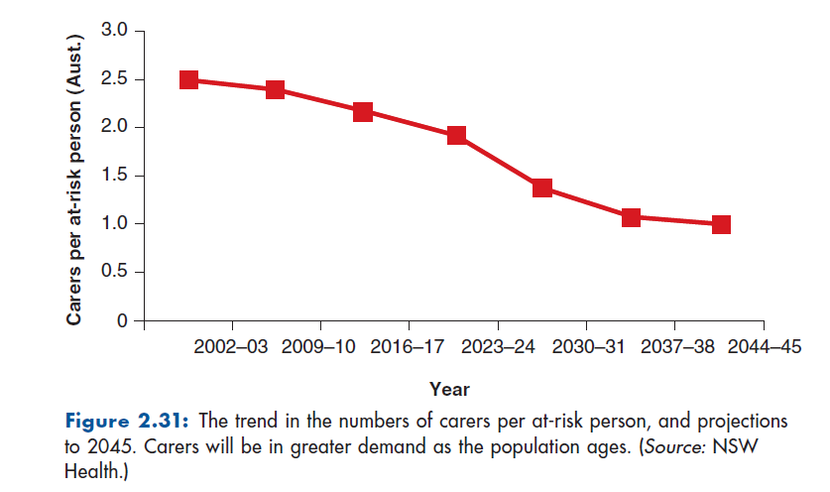

Inquiry

- Assess the impact of a growing and ageing population on carers of the elderly and volunteer organisations.
- Investigate reasons for the projected shortage of carers in the future.
- Suggest measures that could be taken to encourage people to carry out caring and voluntary activities.

Read the article below and answer the following questions
