Groups Experiencing Health Inequities – ATSI 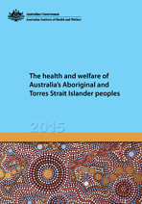
Google the AIHW – The Health and Welfare of Australia’s Aboriginal and Torres Strait Islander Peoples: 2015 report and answer the questions below:

What is the purpose of the report? __________________________________________________________________________________________________________________________________________________________________________________________________________________________________________________________________________________________________________________________________________________________________________________________________________________________
What are the two most common causes of death among ATSI peoples?
____________________________________________________________________________________________________________________________________________________________________
Investigate whether Indigenous Australians are accessing primary health care services more or less than they previously used to? Provide possible reasons for this change.
____________________________________________________________________________________________________________________________________________________________________________________________________________________________________________________________________________________________________________________________________________________________________________________________________________________________________________________________________________________________________________
Identify one determinant of health mentioned in the report and analyse the contribution to inequities experienced by ATSI people. Present this as a mind map.

