Task 1 - Health Inequities

Socioeconomically Disadvantaged People

Table of Contents
Introduction…………………………………………………………………………………. 2
Nature and Extent of Health Inequities .………………………………………………….. 2
Life Expectancy ……………………………………………………………………... 2
Morbidity .…………………………………………………………………………….3
Mortality .……………………………………………………………………………. 4
Health Determinants ……………………………………………………………...……….. 4
Sociocultural ...…………………………………………………………………….… 4
Socioeconomic ………………………………………………………………….…… 4
Environmental ..……………………………………………………………………… 5
Roles of Groups in Addressing Inequities ...………………………………………………. 5
Individuals .…………………………………………………………………………... 5
Communities .………………………………………………………………………... 5
Governments ..……………………………………………………………………..… 5
Conclusion….…………………………………………………………..…………..……….. 6
References .………………………………………………………………………………….. 6

Introduction
The purpose of this report is to display research and results surrounding the health status and health inequities experienced by socioeconomically disadvantaged people Australia’s society.

Socioeconomic factors are important determinants of health and wellbeing in Australia.
There is a consistent relationship between an individual’s socioeconomic status (SES) and their health. The higher a person’s income, education or occupation level, the healthier they tend to be.

Nature and extent of health inequities
Life expectancy
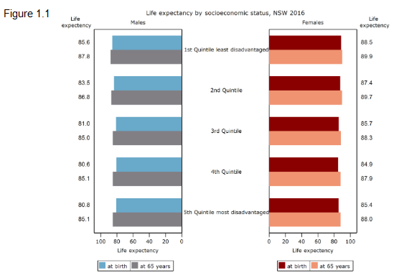
Life expectancy is a statistical measure of the average time a person is expected to live. Socioeconomically disadvantaged people tend to have a lower life expectancy, increased rates of premature death and are sick more often, compared to those from a higher economic level. Data surrounding life expectancy in NSW collected by the NSW Government is shown below in figure 1.1. The report found that at birth there was a life expectancy gap between SES groups ranging between 3 and 5 years. This trend found in NSW was common in the data found nationally.

Since 2001 life expectancy for socioeconomically disadvantaged people has been improving, as displayed below in figure 1.2.

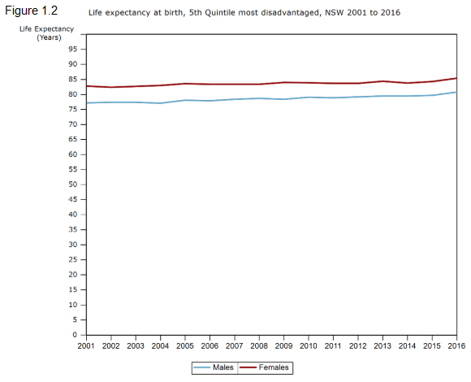

Morbidity
Morbidity refers to the patterns of illness, disease and injury that do not result in death. In 2016, the prevalence of most chronic diseases was substantially higher among adults with low SES (Australian Institute of Health and Welfare, 2016). Research found that diabetes was 2.6 times higher, as well as coronary heart disease and stroke being 2.2 times higher than those in the highest socioeconomic group. The incidence of lung cancer was 1.6 times higher in the lowest socioeconomic groups, most likely due their higher rates of smoking. As well as mental health issues being 1.4 times more common. Socioeconomically disadvantaged people are more likely to suffer from most of the common chronic diseases including arthritis, asthma and kidney disease, compared to the highest socioeconomic group, as displayed in the table below.
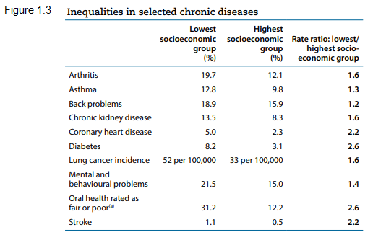

Mortality
Mortality is the number of deaths in a group of people or from a particular disease. Mortality from all causes in the socioeconomic disadvantaged group was 29% higher compared to the highest group (AIHW 2016). Potentially avoidable death rates and premature deaths rates were 1.8 times higher in the lowest socioeconomic group than in the highest socioeconomic group; as well as infant mortality being significantly higher (AIHW 2016). The lowest socioeconomic group had higher death rates in coronary heart disease, cerebrovascular diseases and dementia and alzheimer disease as seen in figure 1.4.
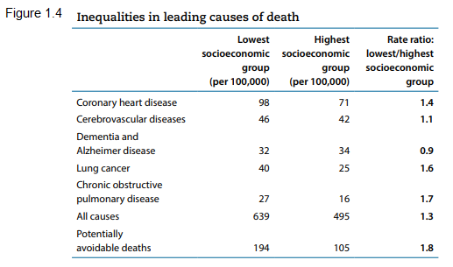

Health Determinants
Sociocultural
Socioeconomically disadvantaged people’s attitudes and behaviours they place on their own health can be strongly influenced by their family and peers. Habits and behaviours a person is exposed to when they are young influence their adult lives. Socioeconomically disadvantaged people are 3 times more likely to smoke and use illicit drugs; as well as being more likely to have poor dietary habits and being 1.4 times more inactivite (AIHW 2016); most likely a result of bad influences from both family and peers. This may lead to them becoming overweight, having high blood pressure and cholesterol, which results in further health issues. It has been found that people of low socioeconomic status are less likely to access preventative health measures such as immunisations, dental check ups and pap smears, most likely a result of the practices of family and friends.

Socioeconomic
Education, employment and income are strongly linked to health. Without a good education, employment options are limited and income will be minimal. Socioeconomically disadvantaged people attend fewer hours of early childhood education, have lower attendance at school, are more likely to leave school early, and are less likely to go to university (Mitchell Institute 2015). This can have a negative impact of their health as they are less informed and unaware of the impact of risk factors such as smoking, excessive drinking, sunbaking and speeding. They also may be unaware of resources available to them such as free breast and skin cancer checks. Low SES people also have higher rates of unemployment (Mitchell Institute 2015) which affects their ability to achieve good health; as dental and medical specialists can be expensive, as well as fresh healthy food, sport registrations and gym memberships.

Environmental
Environmental factors such as geographical location and access to health services and technology also affect the health of individuals. People with a low socioeconomic status commonly live in crowded and poor housing conditions. They experience higher rates of homelessness and decreased capacity to access recreational facilities. Higher rates of socioeconomically disadvantaged people live in rural and remote areas (AIHW 2016), meaning they have poorer access and greater distances to travel for health services and care. This can affect their health as for many it may not be possible to access the care and services they require.

Roles of Groups in Addressing Health Inequities
Individuals
Many factors that affect an individual’s health are non modifiable but there are ways in which everyone can take responsibility and action towards improving their own health, and encourage others to do the same. By choosing to stay in school, individuals are able to learn of healthy choices through the kindergarten to year 10 PDHPE syllabus. By being more informed about health, they can encourage good health choices such as not smoking and to access screening tests and services, to family and friends. Parents can also address inequities by learning better health practises, and setting a good example for their children on important issues such as diet, nutrition and physical activity.

Communities
Communities can also contribute to addressing health inequities. Health promotion strategies by non government organisations, such as the Heart Foundation and Cancer Council, and community groups, such as PCYC and ‘Youth of the Streets’, aim to address inequities and provide programs and support for socioeconomically disadvantaged people. Local community groups provide opportunities for people to get involved in health promoting activities such as walking groups, community vegetable gardens, creches at gyms and language translators for migrants.

Governments
The government plays a large role in addressing health inequities, by attempting to make health in Australia more equitable for all groups and individuals. Australia’s health care system, Medicare, is partially government funded. This provides all Australians with access to affordable health care. Medicare enables many general practitioners to ‘bulk bill’ meaning that all or most of the cost of the appointment is covered by Medicare. The Pharmaceuticals Benefit Scheme reduces the cost of many prescription medications. The Department of Human Services’ Centrelink, provides financial support to those who require it. The NSW government also provides the Active Kids Rebate which gives each school-aged child a $100 voucher to be used for registration in a sports club, promoting physical activity. These government provided policies and programs are designed to improve the access of socioeconomically disadvantaged people to health and recreational services.

Conclusion
Within Australia, socioeconomically disadvantaged people experience many health inequities as outlined in this report. The extent of these inequities is evident in the lower life expectancy, and the higher rates of morbidity and mortality. Many of these inequities are results of several health determinants, in particular, the socioeconomic factors. Several of these inequities can be addressed and reduced through the collaboration and partnership between individuals, communities and governments.

References:
- Abs.gov.au. (2018). 4250.0.55.001 - Perspectives on Education and Training: Social Inclusion, 2009. [online] Available at: http://www.abs.gov.au/ausstats/abs@.nsf/Lookup/4250.0.55.001Main+Features32009 [Accessed 4 Dec. 2018].

- Aihw.gov.au. (2018). Australia's Health 2016. [online] Available at: https://www.aihw.gov.au/getmedia/405d9955-c170-4c39-a496-3839059149f7/ah16-5-1-health-across-socioeconomic-groups.pdf.aspx [Accessed 28 Nov. 2018].

- Aihw.gov.au. (2018). Health inequalities in Australia. [online] Available at: https://www.aihw.gov.au/getmedia/0cbc6c45-b97a-44f7-ad1f-2517a1f0378c/hiamhbrfhsu.pdf.aspx?inline=true [Accessed 4 Dec. 2018].

- Healthstats.nsw.gov.au. (2018). HealthStats NSW Life expectancy by socioeconomic status, trend. [online] Available at: http://www.healthstats.nsw.gov.au/Indicator/bod_lexbth/bod_lexbth_ses_trend [Accessed 28 Nov. 2018].

- HSC PDHPE. (2018). Australia's Health 2016 - Socioeconomically Disadvantaged People. [online] Available at: https://www.pdhpe.net/australias-health-2016-socioeconomically-disadvantaged-people/ [Accessed 4 Dec. 2018].

- HSC PDHPE. (2018). Socioeconomically Disadvantaged People. [online] Available at: https://www.pdhpe.net/health-priorities-in-australia/what-are-the-priority-issues-for-improving-australias-health/groups-experiencing-health-inequities/socioeconomically-disadvantaged-people/ [Accessed 4 Dec. 2018].

- Improving PDHPE. (2018). Groups Experiencing Health Inequities – Improving PDHPE. [online] Available at: http://www.improvingpdhpe.com/hsc-notes/groups-experiencing-health-inequities-2/ [Accessed 3 Dec. 2018].

- Mitchell Institute. (2018). Socio-economic disadvantage and educational opportunity persistently linked - Mitchell Institute. [online] Available at: http://www.mitchellinstitute.org.au/fact-sheets/socio-economic-disadvantage-and-educational-opportunity-persistently-linked/ [Accessed 4 Dec. 2018].

- Prezi.com. (2018). Socioeconomically Disadvantaged People. [online] Available at: https://prezi.com/fmgodxcixvsg/socioeconomically-disadvantaged-people/ [Accessed 4 Dec. 2018].

- Sport.nsw.gov.au. (2018). Fact sheet: Active Kids Rebate program | Office of Sport. [online] Available at: https://sport.nsw.gov.au/sectordevelopment/activekids/fact-sheet [Accessed 4 Dec. 2018].

