HEALTH INEQUITIES IN AUSTRALIA
People in Rural and Remote Areas
BY ANNA RYAN

Table of Contents
Introduction2
Nature and Extent of Health Inequities3
Mortality3
Morbidity3
Life Expectancy3
Health Determinants3
Socio Cultural4
Socio Economic5
Environmental6
Roles of Groups in Addressing Inequities3
Individuals6
Communities6
Governments6
Conclusion3
Bibliography3

Introduction
The purpose of this report is to identify the health inequities experienced by individuals living in rural and remote areas. These inequities will be investigated through an analysis of the nature and extent of the problem, in addition to identifying health determinants that are responsible for these trends. A discussion into the roles of different groups in addressing health inequities will also be detailed in this report.
For the purpose of policy development within Australia, the Australian Bureau of Statistics (ABS) has created a structure which is redefined after each census, known as The Australian Statistical Geography Standard (ASGS) Remoteness Structure. This mechanism ranks areas according to remoteness, describing regions as major cities, inner regional, outer regional, remote or very remote with each region reflecting population characteristics and distance from population centres. (Rural Flying Doctor Service 2016).

Figure 1. The Australian Statistical Geography Standard 2011
(Australian Bureau of Statistics 2013a; RFDS 2016)
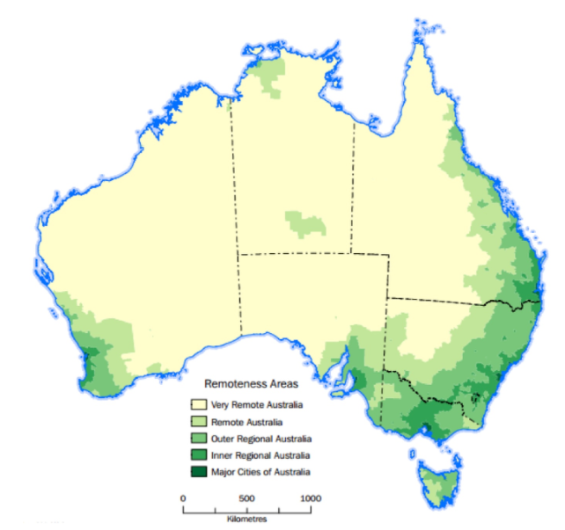

Nature and Extent of Health Inequities

Mortality
Mortality measures the frequency of death occurrences in a specific population at a specific time. Australian mortality rates increased with remoteness, with Very Remote having 1.5 times higher than the rate of Major Cities (Australian Bureau of Statistics 2013; PDHPE.net). Coronary Heart Disease was identified as the leading cause of death, followed by circulatory diseases, motor vehicle accidents and Chronic Obstructive Pulmonary Disease. (PDHPE.net)

Morbidity

Life Expectancy
Life expectancy is determined at birth and refers to the amount of years a person is expected to live, based on current death rates. An Australian Institute of Health and Welfare Report (2008), found life expectancy to be decreasing with remoteness. Males born in the period of 2002-2004 and living in a Major City were expected to live until 79 years of age, while their Very Remote counterparts were only expected to live until the age of 72.1 years. Overall, females had a slightly higher life expectancy with those living in Major Cities expected to live until 88 years of age and those in Very Remote areas only expected to live for 77.6 years. A difference of 6.9 years and 2.4 years for males and females respectively.

Health Determinants

Socio Cultural
Socio cultural health determinants of rural people relate more specifically to the influence of family and peers. The practice of poor health indicators by parents such as smoking, being obese or having low rates of physical activity can transfer to children, modelling similar risk behaviours as they age. Furthermore, the percentage of ATSI peoples in rural and remote areas is significant compared to other areas, which may also account for poorer health outcomes in these regions. (PDHPE.net) Meanwhile, males in rural and remote areas have significantly substandard health compared to their urban counterparts due to community attitudes that illness and injury is part of daily life, and as such, are less likely to seek help for chronic conditions. (Outcomes 2 PDHPE 2013)

Socio Economic
As stated in the Sydney Morning Herald “Heart Foundation data shows healthiest hearts in Australia” article "From Coffs Harbour, to Kiama, to Wagga Wagga, we heard that a lack of accessible, affordable healthy food, nutrition education… are key barriers to families being able to lead healthy, active lives.” (Esther Han 2017) Food cost in remote areas is approximately 20% higher than that of urban areas, while variety decreases and tends to be poorer, affecting diets due to limited availability of fresh fruit and vegetables. This is grossly imbalanced as incomes are 20% lower in rural areas and can significantly fluctuate as they are dependent upon environment due to the predominance of farming in rural areas. Socio economic status decreases with remoteness, and is often cited as a main reason for poorer health outcomes of rural living people. (Rural Health: Determinants 2011) Lower levels of education due to limited access and greater exposure to injury within occupations of farming and mining due to machinery handling, create further issues for the health of rural and regional people. (Outcomes 2 PDHPE 2013)

Environmental
To maintain good health, individuals must have regular access to services. Subsequently, it is the shortage and uneven distribution of health workers in rural and remote areas which can determine health inequities. (Outcomes 2 PDHPE 2013). As depicted in Figure 2, the prevalence of health workers such as physiotherapists, general practitioners, specialists and dental services significantly decreases as communities become more remote. With the exception of nurses whom are only 10% lower in Very Remote areas due to Health at Home initiatives and Community Nursing. Therefore an environment of limited healthcare access due to distance from services, fuel cost and transport availability can prevent sufferers of chronic disease from accessing regular treatment (SMH, Esther Han 2017) Other environmental risks such as that created by long durations spent on roads and poor road quality, coupled with limited access to sufficiently fluoridated water, can have detrimental impacts on health.
Figure 2
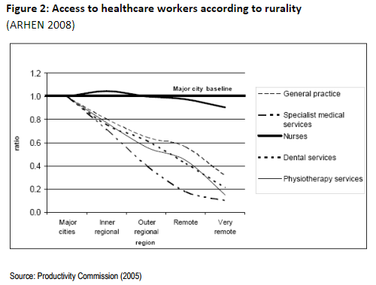

Roles of Groups in Addressing Inequities

Individuals
Individuals can take responsibility for their health choices, reducing their participation in risk behaviours such as alcohol and drug use. As people living in rural and remote areas are more likely to have lower levels of education, (Rural Health: Determinants 2011) which negatively impacts health, individuals can become empowered, building skills and knowledge by completing school and even university resulting in better employment prospects and therefore higher financial stability. Such education can then be applied by individuals in personal health promoting behaviours while supporting others to do the same.

Communities
Communities are responsible for ensuring that individuals are provided with environments that support health, such as through promotion of health protective behaviours and preventative services. Examples of this include the provision of affordable accommodation to rural people when attending health services or hospitals in the city, as is provided by Ronald McDonald House and the Country Women’s Association (Health Direct 2017). Communities can also liaise with government agencies to ensure health professionals are attracted to and retained to serve rural areas (Improving PDHPE 2015) such as Multi-Purpose Service Programs which connect with and form a range of community health services tailored to the needs of rural areas. (My Aged Care.gov 2017)

Governments
The role of the government is to allocate funding and health professionals to rural and remote areas. It achieves this through the Commonwealth Government Bonded Medical Program and more easily accessible entry pathways into undergraduate medicine for students living in rural and remote areas such as the Rural Student Entry Scheme (UNSW Medicine 2012). This scheme reduces the ATAR needed to be accepted into the degree subsequently narrowing the competition pool and in return, students are required to complete some years of their medical placement in rural areas. The Royal Flying Doctor Service is another government funded initiative which enables ease of access of patients to professionals in remote areas. Telehealth psychological services is another service aimed towards people in rural areas. As of 2017, the Federal Government has funded Medicare rebates for this service which reduces patient travel and increases accessibility of psychologists in addressing the immense issue of mental health in rural areas. (Health Times 2017)

Conclusion
In conclusion, significant health inequities lie within the population group of people living in rural and remote areas, expressed by high rates of morbidity and mortality accompanied by low life expectancies compared to those living in urban areas. These inequities are the result of many health determinants, however these detrimental statistics can be addressed by the cooperation of individuals, communities and governments.

Bibliography
Nature and Extent
https://www.aihw.gov.au/getmedia/354a7e07-bf35-4e54-a7e6-fc6659789b0f/rrrh-ihsdh.pdf.aspx?inline=true
Health determinants
http://arhen.org.au/wp-content/uploads/2015/06/chap1.pdf
Outcomes 2 PDHPE HSC 2013
https://www.pdhpe.net/health-priorities-in-australia/what-are-the-priority-issues-for-improving-australias-health/groups-experiencing-health-inequities/people-in-rural-and-remote-areas/
http://www.smh.com.au/nsw/heart-foundation-data-shows-which-groups-have-the-healthiest-hearts-in-australia-20171009-gyx598.html Heart Foundation data shows which groups have the healthiest hearts in Australia
Esther Han
Published: October 10 2017 - 12:15AM

Role of… in addressing
http://ruralhealth.org.au/sites/default/files/publications/factsheet-determinants-health-rural-australia.pdf
https://rcs.med.unsw.edu.au/rural-student-entry-scheme
http://www.improvingpdhpe.com/hsc-notes/groups-experiencing-health-inequities-2/
https://www.myagedcare.gov.au/multi-purpose-services-program
https://www.healthdirect.gov.au/new-south-wales-rural-and-remote-health-services
https://healthtimes.com.au/hub/psychology/9/news/kk1/telehealth-boost-for-rural-and-remote-psychology-services/2506/

