2011 Question 22
Identify FOUR different types of health facilities or services in Australia. 2 Marks
____________________________________________________________________________________________________________________________________________________________________________________________________________________________________________________________________________________________________________________________________________________________________________________________________________________________________________________________________________________

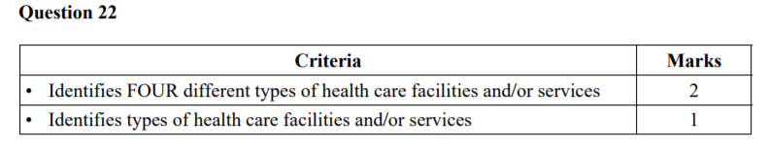
Question 22 Sample answer:
Health facilities or services in Australia include:
• hospitals
• aged-care homes
• Meals on Wheels
• in-home nursing.
Examples should reflect different ‘types’ of health care facilities and/or services.

2012 Question 21
Describe the advantages of Medicare for Australian citizens. 3 Marks
______________________________________________________________________________________________________________________________________________________________________________________________________________________________________________________________________________________________________________________________________________________________________________________________________________________________________________________________________________________________________________________________________________________________________________________________________________________________________________________________________________________________________________________________

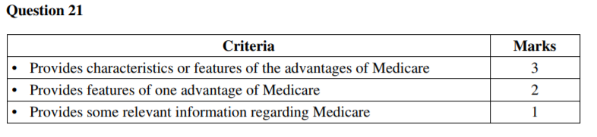
Question 21 Sample answer:
Medicare is Australia’s universal health care system ensuring equality of access for all Australian citizens to free or partially funded medical, optometrical and hospital care with the option of choosing private health care for other services.

2014 Questions 22
What are the responsibilities of each of the three levels of government for the delivery of health services in Australia? 4 Marks
________________________________________________________________________________________________________________________________________________________________________________________________________________________________________________________________________________________________________________________________________________________________________________________________________________________________________________________________________________________________________________________________________________________________________________________________________________________________________________________________________________________________________________________________________________________________________________________________________________________________________________________________________________________________________________________________________________________________________

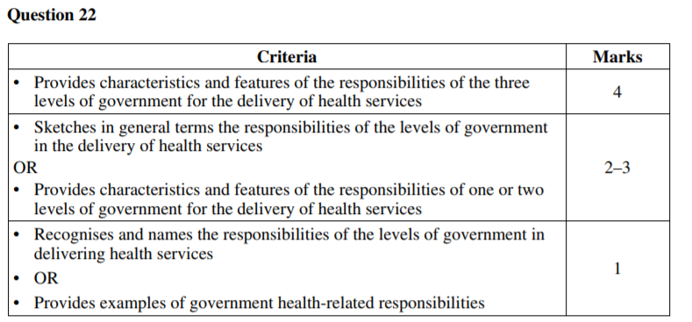

Commonwealth: eg policy development, legislation/laws, funding to state government, Medicare (levy and scheme) and PBS, repatriation hospitals, health promotion strategies
State/Territory: eg health services such as hospitals, mental health services, women’s health, Aboriginal health, dental health, health promotion
Local: eg enacting policy such as health and hygiene regulations, environmental health and community health services, early childhood centres, sexual health clinics, counselling, health promotion, waste disposal, meals on wheels

2015 Question 21
What are the advantages to Australians of having a public health care system? 3 Marks
______________________________________________________________________________________________________________________________________________________________________________________________________________________________________________________________________________________________________________________________________________________________________________________________________________________________________________________________________________________________________________________________________________________________________________________________________________________________________________________________________________________________________________________________

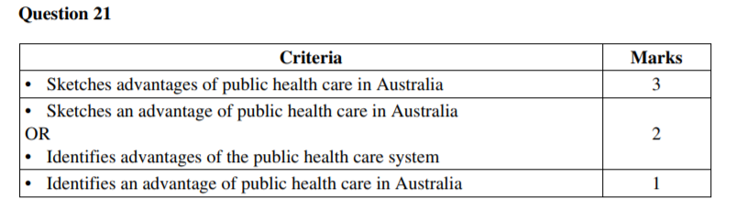
Sample answer:
Australia’s public health care system is supported by Medicare. Medicare allows Australians to receive the basic level of health care, including their own choice of general practitioner, or whether to seek private health cover. Medicare provides free or subsidised medical treatment (Pharmaceutical Benefits Scheme) where costs for Medicare is subsidised or free for chronic illnesses. Medicare also provides free public hospital care. Medicare is a diverse system which applies for all Australians.
Answers could include:
• Access
• Free if GP bulk bills/subsidised GP visits
• Subsidised medication on PBS
• Free treatment in public hospitals

2015 Questions 24
To what extent is access to health care facilities and services equitable for all Australians? 8 Marks
________________________________________________________________________________________________________________________________________________________________________________________________________________________________________________________________________________________________________________________________________________________________________________________________________________________________________________________________________________________________________________________________________________________________________________________________________________________________________________________________________________________________________________________________________________________________________________________________________________________________________________________________________________________________________________________________________________________________________________________________________________________________________________________________________________________________________________________________________________________________________________________________________________________________________________________________________________________________________________________________________________________________________________________________________________________________________________________________________________________________________________________________________________________________________________________________________________________________________________________________________________________________________________________________________________________________________________________________________________________________________________________________________________________________________________________________________________

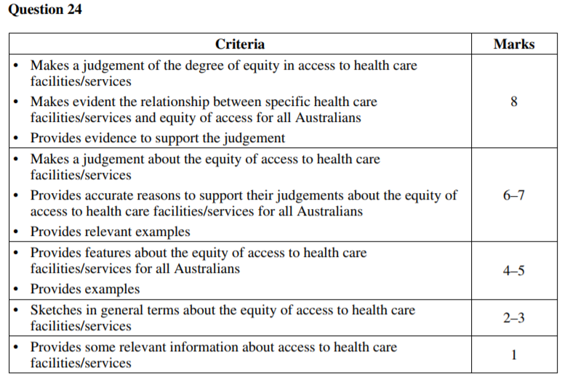
Sample answer:
It is to a moderate extent that health care facilities and services are equitable for all Australians as there are significant concerns for subgroups of the population including Aboriginal and Torres Strait Islanders (ATSIS), those of low socioeconomic status (SES), those living in rural and remote areas, and migrant groups who experience a lower quality of health. ATSIS experience a significantly lower life expectancy (12 years less) than nonATSIS and are more likely to die from preventative causes of disease. Although there are programs to enable them to access medical services, they still experience a significantly lower health status. This is shared by those of lower SES, who have limited access to health services because of lack of affordability. Although Medicare provides free treatment for all, the choice of doctor or hospital is not allowed and there are usually long waiting lists for elective surgery. Similarly those living in rural and remote areas experience accessibility issues as a result of distance and the generally limited amount of health services available. The government, aware of this inequitable distribution, funds the Royal Flying Doctor service in an attempt to provide health care assistance to those in rural and remote areas with great success. In addition, migrant populations generally experience inequitable services as a result of language barriers. Governments have made attempt to change this through provision of information in a multiplicity of languages. Thus, although there is significant difference between the accessibility and affordability of services the government is making efforts to amend this.
Answers could include:
• Equity: Medicare, public health care services/facilities, Pharmaceutical Benefits Scheme
• Inequities related to socioeconomic, sociocultural or environmental determinants
• Health promotion initiatives designed to address equity issues
• Groups experiencing health inequities, eg Aboriginal and Torres Strait Islander peoples, people living in rural and remote areas, overseas born people

