2010 Question 22
(a) Describe TWO action areas of the Ottawa Charter. 4 Marks
____________________________________________________________________________________________________________________________________________________________________________________________________________________________________________________________________________________________________________________________________________________________________________________________________________________________________________________________________________________________________________________________________________________________________________________________________________________________________________________________________________________________________________________________________________________________________________________________________________________________________________________________________________________________________________________________________________________________________________________________________________________________________________________________________________________________________________

(b) Argue the benefits of applying the Ottawa Charter to ONE health promotion initiative. 8 Marks
________________________________________________________________________________________________________________________________________________________________________________________________________________________________________________________________________________________________________________________________________________________________________________________________________________________________________________________________________________________________________________________________________________________________________________________________________________________________________________________________________________________________________________________________________________________________________________________________________________________________________________________________________________________________________________________________________________________________________________________________________________________________________________________________________________________________________________________________________________________________________________________________________________________________________________________________________________________________________________________________________________________________________________________________________________________________________________________________________________________________________________________________________________________________________________________________________________________________________________________________________________________________________________________________________________________________________________________________________________________________________________________________________________________________________________________________________________________________________________________________________________________________________________________________________________________________________________________________________________________________________________________________________________________
2011 Question 23
Evaluate the effectiveness of health promotion initiatives based on the Ottawa Charter in promoting the principles of social justice. 8 Marks
________________________________________________________________________________________________________________________________________________________________________________________________________________________________________________________________________________________________________________________________________________________________________________________________________________________________________________________________________________________________________________________________________________________________________________________________________________________________________________________________________________________________________________________________________________________________________________________________________________________________________________________________________________________________________________________________________________________________________________________________________________________________________________________________________________________________________________________________________________________________________________________________________________________________________________________________________________________________________________________________________________________________________________________________________________________________________________________________________________________________________________________________________________________________________________________________________________________________________________________________________________________________________________________________________________________________________________________________________________________________________________________________________________________________________________________________________________________________________________________________________________________________________________________________________________________________________________________________________________________________________________________________________________________

2013 Question 24
How do the five action areas of the Ottawa Charter address the principles of social justice? Include examples in your answer. 8 Marks
________________________________________________________________________________________________________________________________________________________________________________________________________________________________________________________________________________________________________________________________________________________________________________________________________________________________________________________________________________________________________________________________________________________________________________________________________________________________________________________________________________________________________________________________________________________________________________________________________________________________________________________________________________________________________________________________________________________________________________________________________________________________________________________________________________________________________________________________________________________________________________________________________________________________________________________________________________________________________________________________________________________________________________________________________________________________________________________________________________________________________________________________________________________________________________________________________________________________________________________________________________________________________________________________________________________________________________________________________________________________________________________________________________________________________________________________________________________________________________________________________________________________________________________________________________________________________________________________________________________________________________________________________________________

2014 Question 24
Explain why individuals, communities and governments should work in partnership on health promotion initiatives. Provide examples. 8 Marks
________________________________________________________________________________________________________________________________________________________________________________________________________________________________________________________________________________________________________________________________________________________________________________________________________________________________________________________________________________________________________________________________________________________________________________________________________________________________________________________________________________________________________________________________________________________________________________________________________________________________________________________________________________________________________________________________________________________________________________________________________________________________________________________________________________________________________________________________________________________________________________________________________________________________________________________________________________________________________________________________________________________________________________________________________________________________________________________________________________________________________________________________________________________________________________________________________________________________________________________________________________________________________________________________________________________________________________________________________________________________________________________________________________________________________________________________________________________________________________________________________________________________________________________________________________________________________________________________________________________________________________________________________________________

2015 Question 22
Explain how health services in Australia have been reoriented to address ONE health promotion initiative. 4 Marks
____________________________________________________________________________________________________________________________________________________________________________________________________________________________________________________________________________________________________________________________________________________________________________________________________________________________________________________________________________________________________________________________________________________________________________________________________________________________________________________________________________________________________________________________________________________________________________________________________________________________________________________________________________________________________________________________________________________________________________________________________________________________________________________________________________________________________________

ANSWERS AND MARKING CRITERIA
2010 Question 22
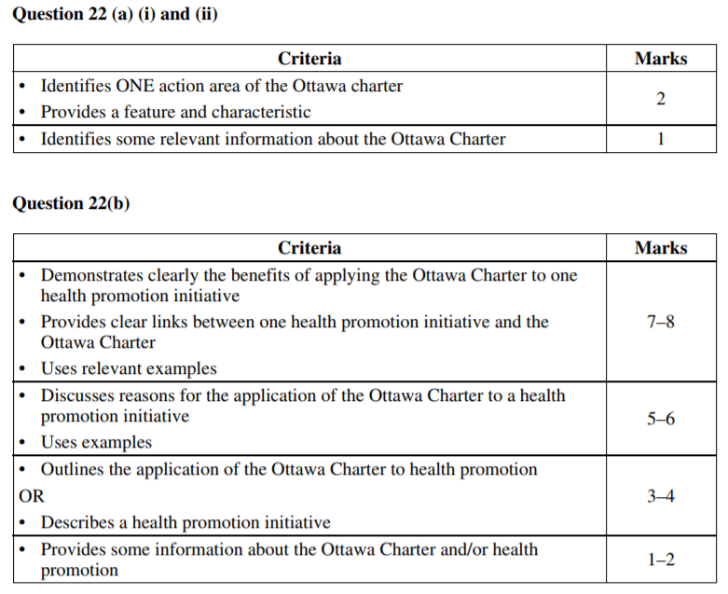
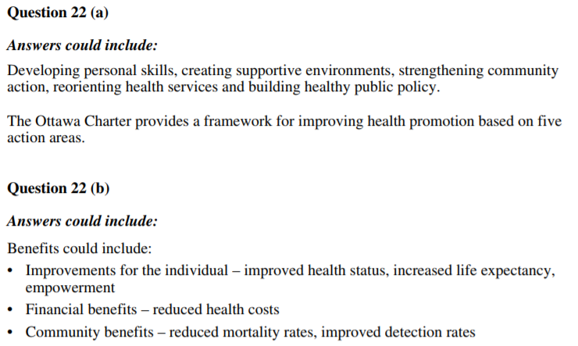

2011 Question 23
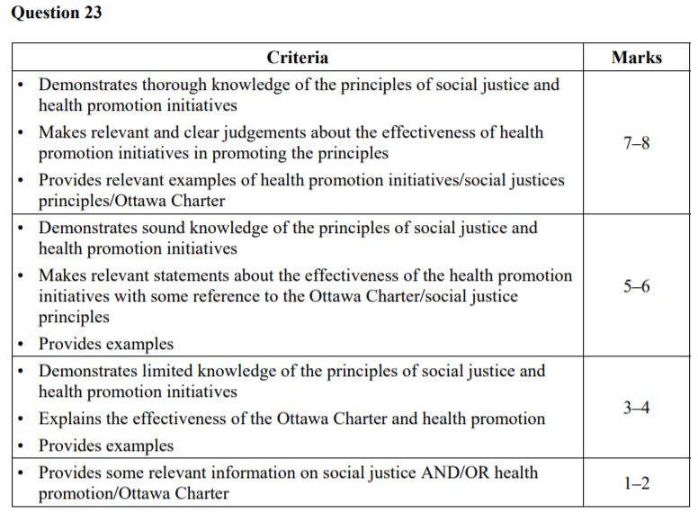
Question 23 Answers could include:
In this context, social justice refers to eliminating inequity in health, promoting the inclusiveness of diversity, and establishing supportive environments for all Australians.
The four principles of social justice as they relate to health are:
• equity – fair allocation of resources and entitlement without discrimination
• access – the availability of health services, information and education
• participation – the empowerment of individuals and communities to be involved in planning and decision-making for good health
• rights – equitable opportunities for all individuals to achieve good health.
Social justice key terms – equity, diversity and supportive environments Examples of health promotion initiatives could include Oxfam Australia’s Close the Gap, which aims to:
• increase Aboriginal and Torres Strait Islanders’ access to health services (access)
• address critical social issues, such as poor housing, nutrition, employment and education (access), among Indigenous Australians
• build Indigenous control and participation in the delivery of health and other services (participation)
• get governments at the state and national level to work in partnership with Indigenous Australian communities, health organisations and experts to develop and monitor a plan to tackle the Indigenous health crisis in Australia (participation).
Developing personal skills can only occur if education is assured for all individuals. Staying on at school until at least Year 10 will undoubtedly positively effect a person’s ability to make informed health decisions. So for equity to be achieved, access to education is imperative. An example of this would be PDHPE lessons, in which information and issues around smoking are discussed.
Diversity is about ensuring that information is relevant to all people, irrespective of their age, gender, culture, geographic location, sexuality or socioeconomic status. This is where the ‘one size fits all’ approach to health promotion reaps little success. Programs must be able to be personalised in order to target all individuals. Consider a pamphlet that describes how to conduct breast self-examinations in order to detect the early signs of breast cancer. This pamphlet would develop the skills of a greater group of women if it was available in many different languages and included self-explanatory graphics that could be understood by all women, regardless of their level of education.
It is crucial for an individual to develop their personal skills if they are going to overcome any negative influence their environment may have on them. Developing personal skills supports the notion of supportive environments by empowering individuals through the teaching of knowledge and skills, which they can pass on to others in their environment. If a parent is educated about healthy food habits, they will provide nutritious foods for their children, which will reduce the chance of them developing a diet-related illness such as diabetes.
Creating supportive environments - Any health promotion initiative that addresses and acknowledges the influence of a person’s environment will have an increased chance of success. If a local council improves the lighting and security of the local bicycle track, it will increase the chance of the track being used by people either in the early hours of the morning or later in the evening. This increased level of availability may encourage members of the community to use the track and therefore improve their physical fitness. This is how a community can assume some responsibility for promoting health.
Reorienting health services - In order for equity to be achieved, health services must be culturally sensitive and respect the diverse needs of all people, irrespective of their cultural backgrounds. Doctors should be aware of how their patients’ backgrounds may influence their health choices, rather than just addressing the symptoms that patients are displaying.
All individuals, irrespective of educational background, should have equal opportunities to train in the promotion of health as well as the provision of health services, in order to increase the health outcomes of their own community and those of others. This would uphold the social justice principle of equity. The benefit of research into health conditions is that it can improve health outcomes for all groups of people, particularly if it encourages change in negative lifestyle behaviours. This aspect of reorientating health services addresses diversity and equity, as all people in the future can reap the positives outcomes of important research, whether it is scientific or social.
Building healthy public policy - Through implementing legislation, policies and fiscal measures, governments can work towards creating equity among individuals and across different populations. Laws can ensure that all people are treated fairly, irrespective of their social markers. For example:
• All workplaces have government-enforced smoking bans that protect both blue-collar and white-collar workers
• The Pharmaceutical Benefits Scheme (PBS) is an example of how the social justice principle of equity is addressed by the Commonwealth Government. The government recognises that not all people can afford the cost of prescription drugs, so it subsidises the cost of medication to assist people from low socioeconomic backgrounds in order to create equal access for everyone.
• The ‘no hat, no play’ policy in primary schools promotes a supportive environment for the good health of children. Since wearing a hat during breaks is compulsory, this protects children from exposure to UV and reduces the chance of them developing skin cancer.
[If students take a look through an initiative such as the National Tobacco Strategy and then link examples from that strategy to equity, diversity and supportive environments, that is also a reasonable method to take

2013 Question 24
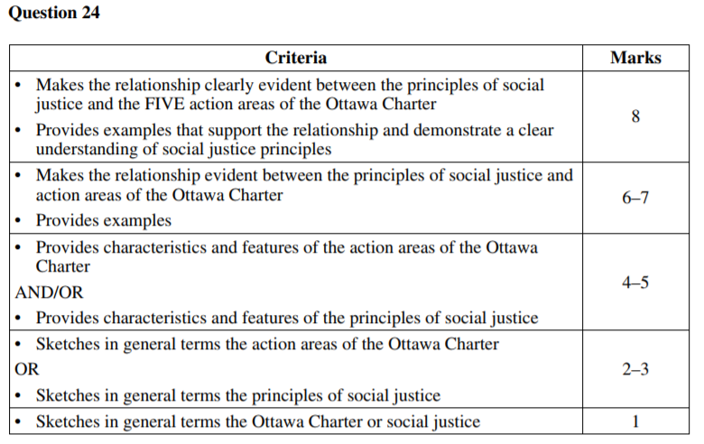
Social Justice Principles (SJP) (participation, equity, access and rights) are an essential foundation for Health Promotion (HP) strategies and are strongly linked in the Ottawa Charter.
Developing Personal Skills (DPS) – individuals use knowledge and skills to make informed decisions and positively influence those around them. SJP linked to DPS are EQUITY and ACCESS; ACCESS to the education and information necessary to develop the skills and EQUITY to ensure access is not limited by economic status, gender, race etc (NSW – compulsory education until 17 yrs).
Creating Supporting Environment (CSE) – increases a person’s chances of making changes to benefit their health. SJP of PARTICIPATION relates to CSE by encouraging individuals and communities to participate in strategies which will benefit/improve their health (using QUIT helpline).
Strengthening Community Action (SCA) – HP is more effective when communities get involved/support. SJP of EQUITY and RIGHTS is reinforced by valuing an individual’s/community’s culture which will strengthen the success of the HP strategy (Relay for Life).
Reorient Health Services (RHS) – encourages health professionals to move beyond traditional medicine and employ diverse treatment methods. EQUITY is addressed in RHS to ensure health services cater for all, irrespective of culture, race, SE (alternative therapies). In addition, the SJP of ACCESS and RIGHTS is used to ensure every Australian has access to our health system (Medicare).
Answers could include:
• Developing personal skills
• Creating supportive environments
• Reorienting health services
• Developing healthy public policy
• Strengthening community action
• Equity
• Diversity
• Supportive environments
2014 Question 24
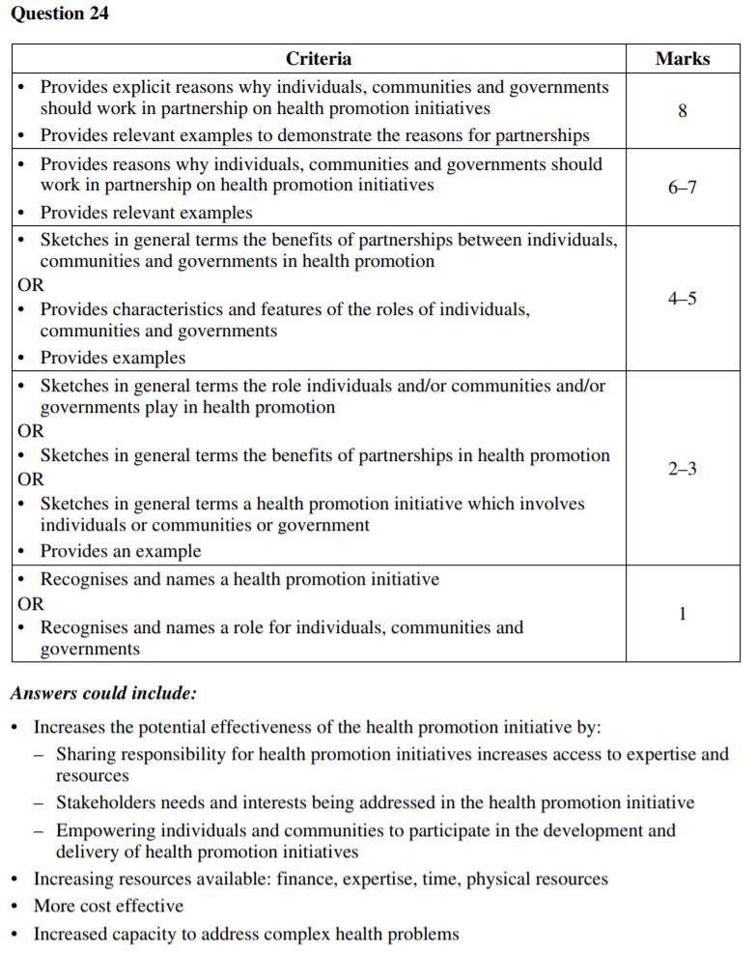

2015 Question 22
