Is Fotu, 9 and 85kg, too big for his teammates’ boots?

By Louise Hall and Katie Benson Parents are calling for the introduction of weight-restricted divisions in junior rugby league because of huge size differences between young players.
The increasing number of children of Pacific Islander background playing in local competitions has seen some players weighing up to 50 kilograms more than other kids in their own age group.
At an under-10s match in Sydney’s west yesterday, nine-year- old Fotu Luani barrelled through opposition players, scoring three tries for Blacktown City. He was one of seven strongly built boys of Islander background in the team.
But parents from the opposing
Colyton-Mount Druitt team called

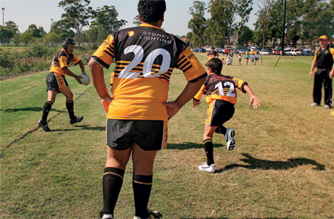for boys such as Fotu, who weighs 85 kilograms and is 168 centimetres tall, to be put up into an older age group.
Donna Meyers, whose son Josh played against Fotu, said she was worried smaller kids could get injured when trying to tackle boys his weight.
‘It’s not his fault but he should be put up against players his own size,’ she said.
But Fotu’s parents, Monitana and Inoke Luani, who are from Tonga, said their son had always been bigger than normal but his skills were on par with other boys his age.
‘I can understand the other parents, they don’t want their son to be
injured, but this is a game where you are working on skill not on weight and I think that’s what it comes down to,’ Mrs Luani said.
‘My son is nine, 10 next month, and to put him in with the under-11s
Blacktown City’s Fotu Luani, 9, foreground

or 12s when they are more skilled than him isn’t right.’
Fotu’s coach, Jim Vanzwan, said
Fotu could not be expected to
compete against older boys with better fine motor skills.
He said Fotu used to be scared of tackling other players for fear of hurting them, but he had taught all his players
the correct technique to avoid injury.
‘It’s not just his size that’s got him where he is, he’s really put in the effort to get himself fit and learn to tackle properly and he tackled his heart out today.’
Blacktown City parents said weight-based divisions could force players as young as nine to play against
18-year-old men.
‘Mentally he’s still a nine-year-old and if you watch the older teams play,

they’ve got much more skill, whereas the under 10s just want to score a try,’ said Carol Padden, mother of Joshua, 9.
Mrs Padden added that rugby league boosted the self-esteem of boys of Tongan, Samoan and Maori heritage.
Primary schools in the Penrith area successfully trialled a weight-restricted division last month.
As well as the usual age divisions, the Panther Trophy held a special competition for children under 48 kilograms.
Melanie Crinion, National Rugby League development officer with the Penrith Panthers, said feedback from parents, teachers and children had been overwhelmingly positive.

The Sun-Herald, 16 July 2006

